**Azure Digital Twins (Preview)**

**Azure Digital Twins Preview** is an **Azure IoT service** that creates **comprehensive models of the physical environment**. It can **create spatial intelligence graphs** to model the **relationships and interactions between people, spaces, and devices**. Whatever your real-world business scenario is, it is likely a corresponding digital instance can be provisioned through Azure Digital Twins. **Azure Digital Twins applies to all types of environments, such as, warehouses, offices, schools, hospitals, and banks**.

**Key Capabilities:**

* **Spatial Intelligence Graph**:

 Is **a virtual representation of the physical environment**. You can use it to model the relationships between people, places, and devices.

* **Digital twin object models:**

Are predefined device protocols and data schema. They align your solution’s domain-specific needs to accelerate and simplify development.

* **Multiple and Nested tenants:**

You can build solutions that scale securely and can be reused for multiple tenants. You also can create multiple subtenants that can be accessed and used in an isolated and secure manner.

* **Advanced compute capabilities:**

With [user-defined functions](https://docs.microsoft.com/en-us/azure/digital-twins/concepts-user-defined-functions), you can define and run custom functions against incoming [device data](https://docs.microsoft.com/en-us/azure/digital-twins/concepts-device-ingress) to send signals to predefined endpoints. This advanced capability improves customization and automation of device tasks.

* **Built in-access control:**

By using access and identity management features such as [role-based access control](https://docs.microsoft.com/en-us/azure/digital-twins/security-role-based-access-control) and [Azure Active Directory](https://docs.microsoft.com/en-us/azure/digital-twins/security-authenticating-apis), you can securely control access for individuals and devices.

* **Ecosystem:**

You can connect an Azure Digital Twins instance to many powerful Azure services. These services include Azure Stream Analytics, Azure AI, and Azure Storage. They also include Azure Maps, Microsoft Mixed Reality, Dynamics 365, or Office 365.

**Introductory video link**:

<https://www.youtube.com/watch?v=TvN_NxpgyzQ>

1. **Microsoft Azure Digital Twins Documentation:**

Let us get started with basic information through Azure digital twins documentation. This is the basic documentation that Microsoft has provided. In this documentation you will get to know all the basic terms related to Azure digital twins. Also, in this documentation, it is provided with basic demo of hotel rooms provisioning. In the output you will see information of wellness of rooms in Json format with required sensor data of temperature, humidity etc. This documentation will also provide good information through resources, references, concepts and tutorials. You can follow these tabs to get good understanding.

Here is the link for documentation:

<https://docs.microsoft.com/en-us/azure/digital-twins/>

Introductory video link for demo in the documentation is given below:

<https://www.youtube.com/watch?v=1izK266tbMI>

In addition, to know about above documentation, **Orielly** has provided good video online course. This course will throw lights on various parts of documentation including code part explanation and basic information. This course will definitely good to provide information about documentation.

Link for the above course is given below:

<https://www.oreilly.com/library/view/introducing-azure-digital/9781484253755/krzyczkowski_Segment2.html>

(This course is free to watch, as you just need to give your information for credentials without giving any payment credits.)

1. **Smart Hotel 360-IOT- Demo:**

Above documentation will not provide all features of Azure digital twins demo like how this service creates graphical view. All this features are provided through Hotel360-Iot demo.

SmartHotel360 uses a **microservice oriented** architecture implemented using containers. For the IoT Demo, there are various services developed in different technologies: .NET Core 2, ASP.NET Core 2, and Angular. These services use different Azure Resources like Digital Twins, App Services, Cosmos DB, Event Hubs, Azure Functions, and IoT Hubs to name a few.

Link for the introductory demo on Hotel360demo:

<https://channel9.msdn.com/Shows/Internet-of-Things-Show/SmartHotel-360-a-demo-powered-by-Azure-Digital-Twins>

Link for the repository:

<https://github.com/microsoft/SmartHotel360-IoT>

In this demo, you can find a [**demo scripts**](https://github.com/microsoft/SmartHotel360-IoT/blob/master/Documents/DemoScript) with a walkthroughs once you have finished the setup of this demo.

Demo Scripts requires following parameters:

1. {Subscription id}

2. {Resource group name}

3. {Resource group location}

4. {App id}

5. {App key}

6. {Service principal id}

7. {AKS service principal app id}

8. {AKS service principal password}

By following above repository, you will get all the parameters required for the demo scripts as shown in below script.

.\deploy.ps1 -**subscriptionId** {subscription id} -**resourceGroupName** {resource group name} -**resourceGroupLocation** {resource group location} -**clientId** {app id} -**clientSecret** {app key} -**clientServicePrincipalId** {service principal id} -**aksServicePrincipalId** {AKS Service Principal App Id} -**aksServicePrincipalKey** {AKS Service Principal Password}

To get **{App key} parameter**, link:

<https://learn.hashicorp.com/terraform/azurerm/authentication-service-principal-client-secret>

* **Create IoT Demo Users:**

After getting above parameters, you need to create IoT Demo users. These can either be users created in your AAD or guest users that you add. For all of these users, you need to collect the Object Id for them and update **/Source/ARM/UserAADObjectIds.json** with those values.

Eg.Updated Demo Users:

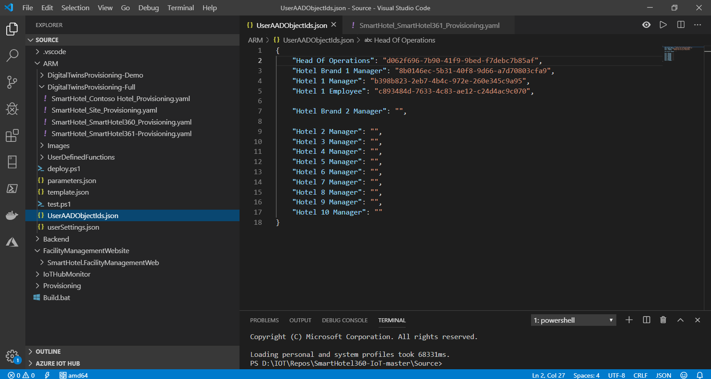

**SmartHotel360-IoTDemo**->**Source**->**ARM**->**UserAADObjectsids.json**

To get Demo users, you can follow bellow path as shown in the picture:

**Home**->**Azure Active directory** ->**Users**->**Search Tab** (Name you want to search)

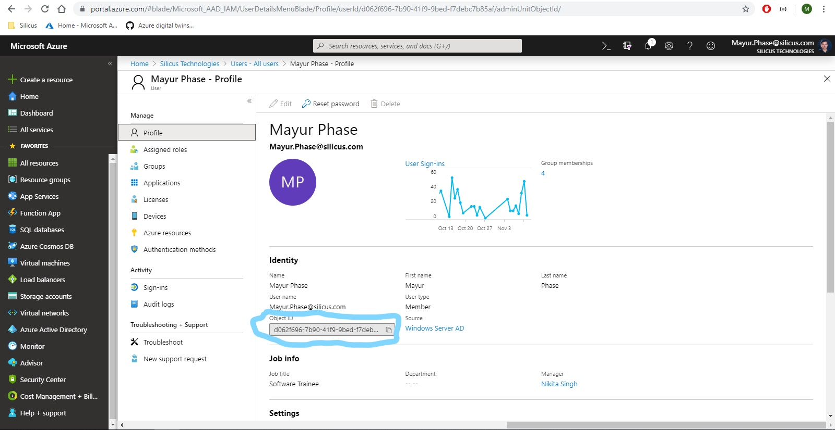

This is for one user, Objects ID for other users can be found by following above path.

After getting successful implementation of above script, all the required resources are created in azure portal as shown below. This whole process takes around 1 hours of time.

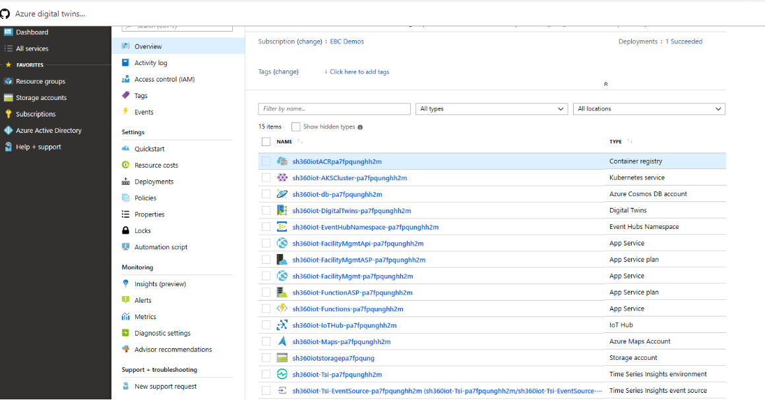

The above process is used for only one hotel to be functional as to reduce cost. If you want, you can make changes as given in **Demo Provisioning Info and through Digital Twins provisioning changes** in repository code to activate all hotels to be functional.

* **User Settings:**

**SmartHotel360-IoTDemo**->**Source**->**ARM**->**UserSettings.Json**

When the **deployment script is complete**, it will output a **userSettings.json** file with information needed for the rest of the deployment. This Json file will provide all the necessary parameters to run the demo.

* **Time Series Insights Access Policy:**

You will need to give the Azure AD Application you created [earlier](https://github.com/microsoft/SmartHotel360-IoT#Set-up-a-Service-Principal-and-register-an-Azure-Active-Directory-application) access to the Time Series Insights environment for the charts to work. After completing, this may need to access for authentication purpose in Azure Active Directory (AAD).

1. Add "aadReplyUrl": "{facility management web reply Uri for ADAL}" this parameter value as shown in below picture:

**Home**->**Azure Active Directory**->**App Registrations** (Search your app and click)

->**Authentication**

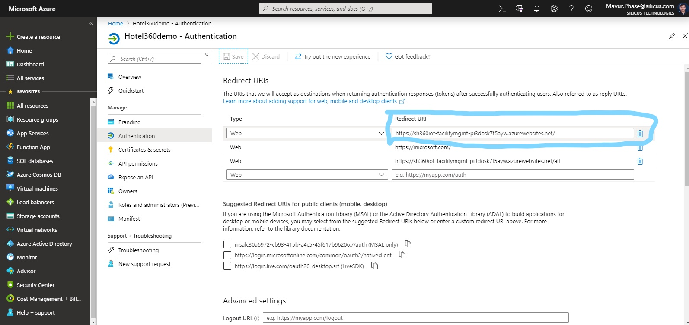

1. Access to ID Tokens as show below.

**Home**->**Azure Active Directory**->**App Registrations** (Search your app and click)

->**Authentication**

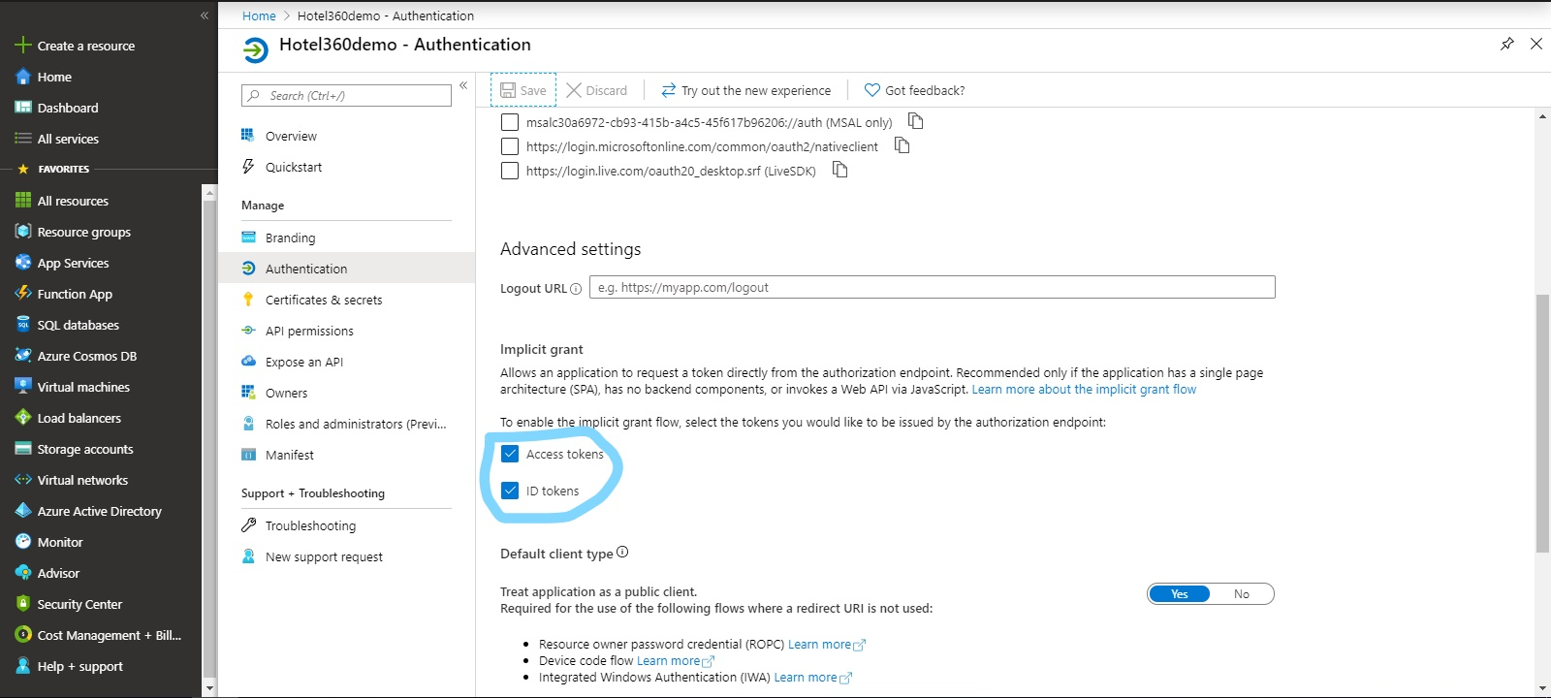

**Success!**

To verify that everything is working correctly, open up the **facilityManagementWebsiteUri** (from the **userSettings.json** in the browser and log in with one of the two users created during the provisioning steps.

For further modification of the application, like xamrin, MXChip devices and other related things, you can follow the given repository to make changes as per required.

**Useful Links and stuff:**

* **Some Errors that occurred while authenticating the applications:**

**1. How to fix “AADSTS700054: response type ‘id_token’ is not enabled for the application” error:**

<https://www.koskila.net/how-to-fix-aadsts700054-response_type-id_token-is-not-enabled-for-the-application-error/>

**2. How to fix “AADSTS50011: The reply address does not match the reply addresses configured" error**:

<https://www.koskila.net/aadsts50011-the-reply-address-does-not-match-the-reply-addresses-configured/>

* **Azure digital twins feedback forum:**

<https://feedback.azure.com/forums/916621-azure-digital-twins>

* **Microsoft Tech Community**(Azure Digital Twins)**:**

<https://techcommunity.microsoft.com/t5/forums/searchpage/tab/message?advanced=false&allow_punctuation=false&filter=location&location=forum-board:Azure-IoT&q=azure%20digital%20twins>

* **At the end of the day what is Digital Twins about?**

(This link will provide insights on Azure Digital Twins through various ongoing projects that are using this service as a documentary view.)

<https://techcommunity.microsoft.com/t5/Azure-IoT/At-the-end-of-the-day-what-is-Digital-Twins-about/m-p/759502>